**TITLE**: AN AI BASED STUDENT TRACKING SYSTEM TO ANALYSE THE STUDENT’S BEHAVIOR

**Team Number**: CSM10

**Team Members**: N. Shiva Kumar, Vundela Vamsi, M Ravi Teja

**GitHub Link**: <https://github.com/siddhu1716/Student_tracking_system>

**Project Overflow:**

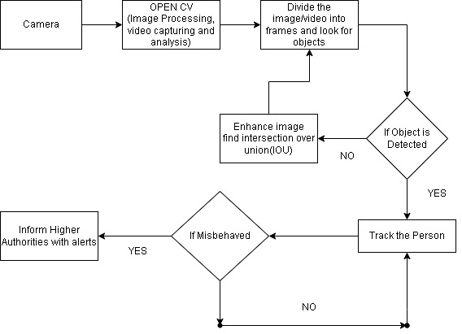

**Work Progress:-**

1. **Completed work**

* Integrated YOLO with Facial Recognication
* Implemented Attendence tracking with name and entry time
* Abnormal Activities Detection using implemented models.

1. **Need to-be Completed**

* Twillo model integration for real-time SMS.
* Improving accuracy for abnormal events
* Training the model with huge data which contains abnormalities (students using mobiles in classroom)

**Need Assistance for:-**

**Issues:**

1. Should integrate the Twillo module in Python for real-time SMS.

2. I am sending only 10 frames per second but still the model is prolonged. I need to sort that out.

3. Facing accuracy problems with the abnormal event.

4. Need to add a module for detecting abnormalities when students are using the phone